Ideation Phase
Brainstorm & Idea Prioritization Template

Date | 23-09-2026
Team ID | SWTID-2026-2008
Project Name | AI BlogNest
Maximum Marks | 4 Marks

Brainstorm & Idea Prioritization:
Step-1: Team Gathering, Collaboration and Select the Problem Statement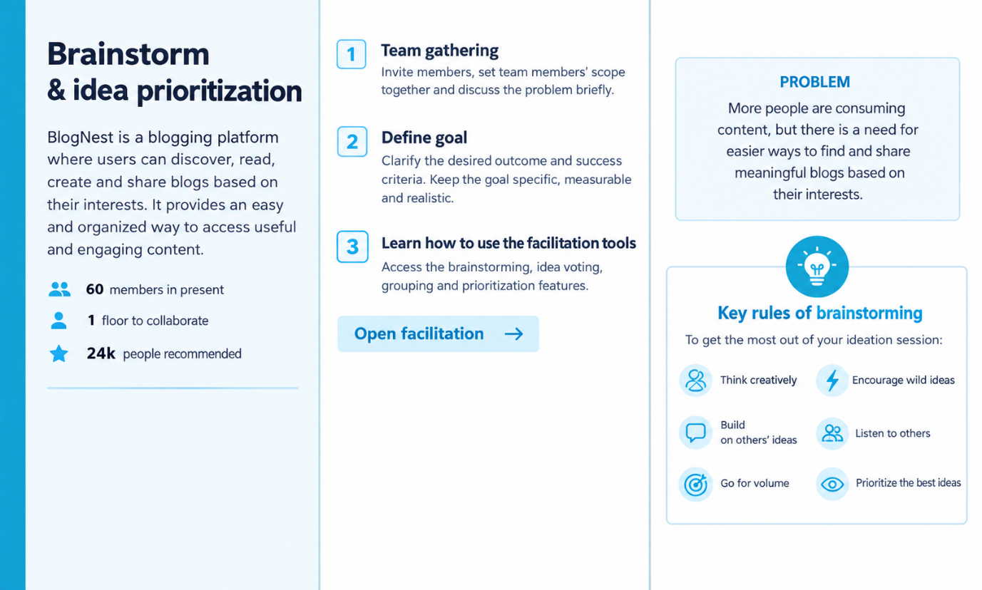

Step-2: Brainstorm, Idea Listing and Grouping
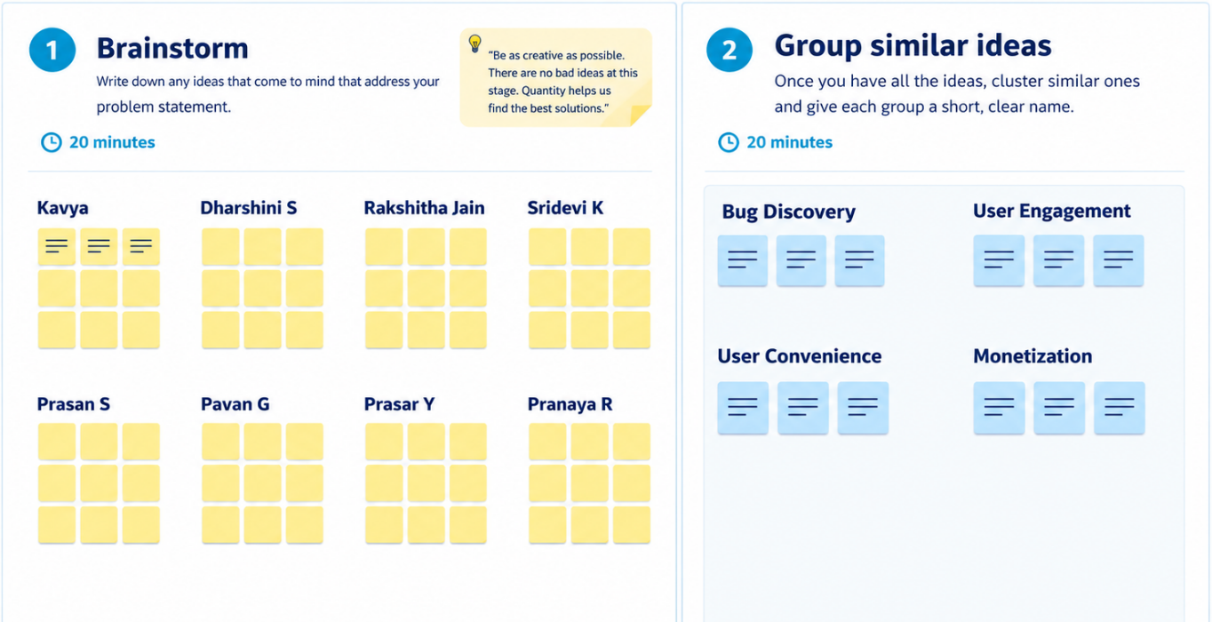

Step-3: Idea Prioritization
